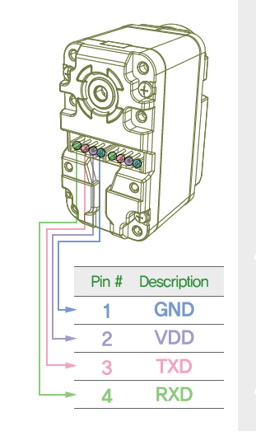

Microcontrolleur

PB6 = Tx

PB7 = Rx